Customer Churn Data Analytics Bank Report

Ahmed Sulaiman Saif 202009528

Abdelaziz Al Mansoori 201901881

Introduction

Understanding client requirements and preferences is crucial in today's competitive retail market. Banks are strongly affected by client relationships, which can affect financial decisions. client satisfaction influences client loyalty, retention, and advocacy as well as service quality. This case study examines retail bank customer satisfaction data to inform strategic and operational choices. By using Customer Survey Data and Demographic Data, we expect to find patterns, correlations, and areas for improvement. Analyzing shop experience feedback and demographic data will give the retail bank a holistic view of the consumer's perspective, helping it improve its customer experience.

Methodology

2.1 Data source

The dataset used for this study originates from customer records specifically focusing on churn rates and customer satisfaction. It appears to span a wide demographic spectrum, encompassing variables such as gender, geography, age, and more. The records not only encapsulate the basic details of each customer, like their unique identification, surname, and credit score, but also delve into deeper metrics that potentially influence customer satisfaction and behavior, such as account balance, tenure with the service, card type, and their engagement status with the platform, indicated by variables like "IsActiveMember". Furthermore, this dataset provides a unique lens into the financial well-being and consumer habits of the subjects, as seen from attributes detailing their estimated salary and the type of credit card they hold. Drawn from real-world scenarios, the dataset is a rich amalgamation of both categorical and numerical data, providing a comprehensive backdrop against which our analyses and interpretations are framed.

2.2 Statistical techniques

Descriptive statistics

Key measures such as the mean, median, and standard deviation were employed to provide an overview of the dataset. Visual tools like histograms and bar charts were utilized to offer a clearer picture of the data distribution and trends.

Hypothesis testing: To determine if geographic location has a significant impact on customer exit rates, a hypothesis test was conducted. The null hypothesis (H0) stated that there would be no difference in exit rates across all geographic locations. The alternative hypothesis (Ha) suggested that the exit rate would differ between at least two geographic locations. A Chi-squared test was utilized to assess the association between geographic location and customer exit rates.

3.Analysis Result

3.1 Descriptive statistics:

**Geography**

**France:** Among customers from France, the mean exit rate is 0.1617 (or 16.17%). Out of 5014 customers, 811 have exited, representing a proportion of 16.17% of the total customers from this region.

**Germany:** In Germany, the average exit rate stands higher at 0.3244 (or 32.44%). Of the 2509 customers hailing from this location, 814 decided to leave, which makes up 32.44% of the total German customer base.

**Spain:** Spanish customers exhibited an exit rate that averaged at 0.1667 (or 16.67%). From the 2477 customers from Spain, 413 have exited, translating to 16.67% of the entire Spanish customer demographic.

**Gender**

**Female:** Among female customers, the mean exit rate is 0.2507 (or 25.07%). Out of 4543 female customers, 1139 have exited, representing a proportion of 25.07% of the total female customers.

**Male:** For male customers, the average exit rate is 0.1647 (or 16.47%). Of the 5457 male customers, 899 decided to leave, accounting for 16.47% of the entire male customer base.

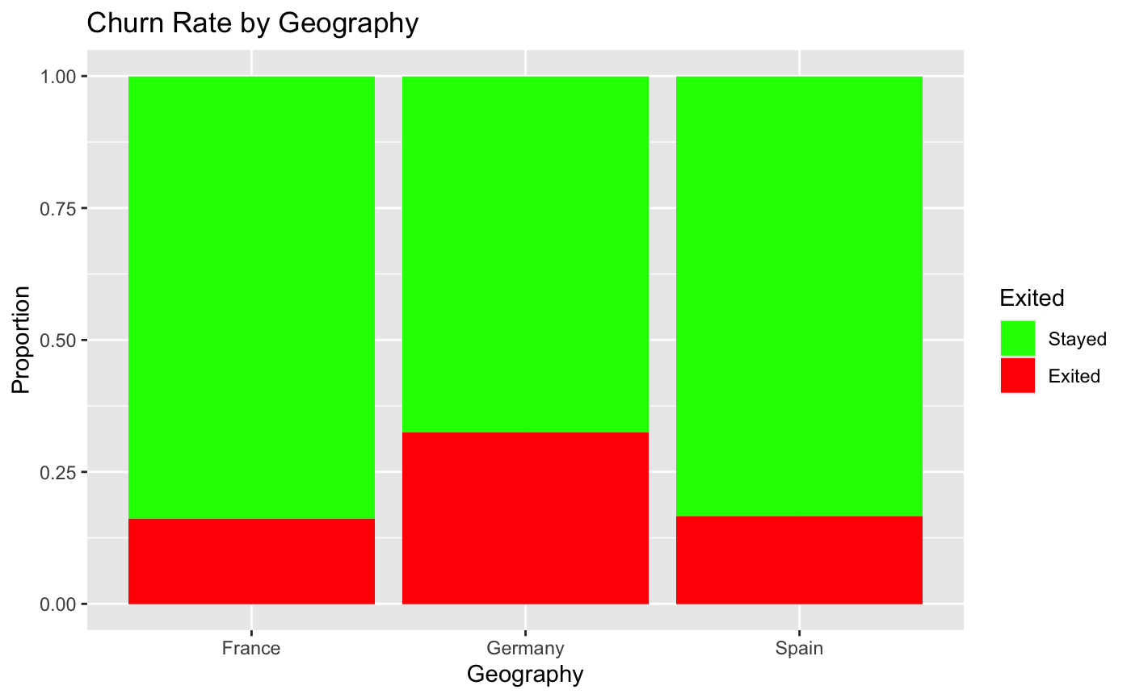

*Figure 1: Number of exited and stayed customer in the different geographical location.*

**Figure 1** displays customer exit rates across France, Germany, and Spain. France and Spain have comparable exit rates near 16%, while Germany stands out with a significantly higher exit rate of 32.44%. This suggests consistent retention challenges in France and Spain, but a more pressing concern in Germany that warrants further investigation.

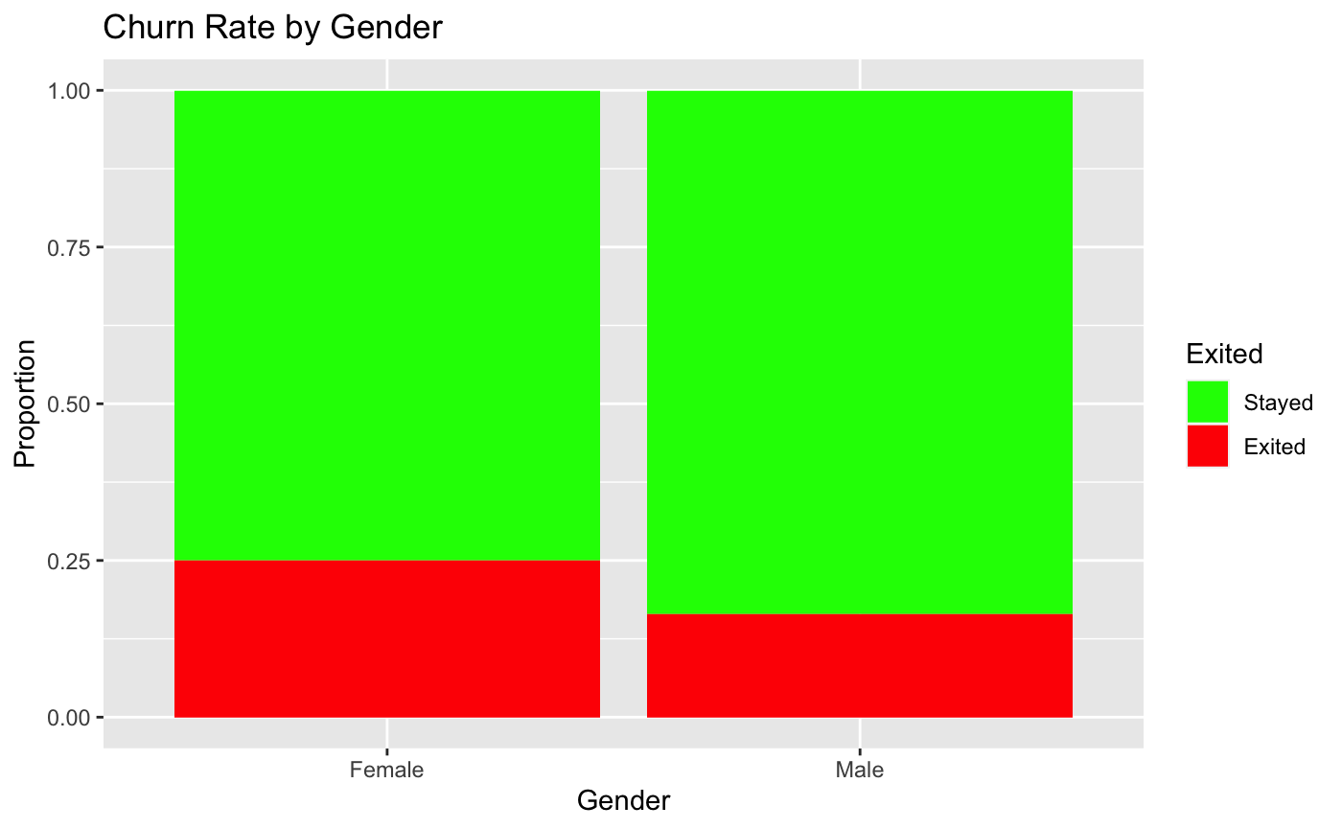 *Figure 2: Number of exited and stayed customer with respect to gender.*

**Figure 2** illustrate customer exit rates across genders: Female and Male. While male customers have an exit rate of about 16.47%, female customers exhibit a significantly higher exit rate of 25.07%. This indicates consistent customer retention with the male demographic. In contrast, there's a more pronounced challenge in retaining female customers that requires additional exploration.

3.2 Hypothesis Testing:

The Chi-squared test yielded an X-squared value of 300.63 with a p-value of < 2.2e-16. Since the p-value is considerably less than the predetermined significance level of 0.05, we reject the null hypothesis. This suggests that the geographic location has a statistically significant impact on customer exit rates.

The Chi-squared test yielded an X-squared value of 112.4 with a p-value of < 2.2e-16. Since the p-value is considerably less than the predetermined significance level of 0.05, we reject the null hypothesis. This suggests that gender has a statistically significant impact on customer exit rates.

Discussion

This case study reveals that both geographic location and gender significantly influence customer exit rates. German customers show a higher exit rate than those from France and Spain. Additionally, female customers are more likely to exit than males. These findings highlight the importance of businesses understanding regional and gender-specific nuances to enhance customer retention strategies.

5.Limitation

It is crucial to recognize certain constraints present in this study. Firstly, the analysis is based solely on three geographic locations and two gender categories, potentially limiting the breadth of insights. This might not fully capture the global intricacies of customer behavior, nor account for all demographic nuances and external factors influencing exit rates.

Moreover, while we have statistics on exit rates. For instance, are female customers leaving due to specific unmet needs or preferences? Or are economic and service factors in Germany contributing more to the exit rates than in France or Spain?

Furthermore, we only observe exit rates at a specific moment, lacking a longitudinal view that might unveil trends or shifts over extended periods. Future studies encompassing more diverse geographic regions, additional demographic categories, in-depth explorations of exit rationales, and longer analysis timelines could provide a richer understanding of the patterns observed.

6. Conclusion

In conclusion, our study reveals that both geographic location and gender play a pivotal role in influencing a customer's decision to stayed or exit the bank. While Germany stands out with a noticeably higher rate of customers leaving compared to France or Spain, gender differences also emerge, with females showing a higher exit rate than males. These findings imply that banks need to be attentive not just to regional dynamics, but also to potential differences in the experiences or expectations of male and female customers.